PRACTICAL_01

PRACTICAL_02

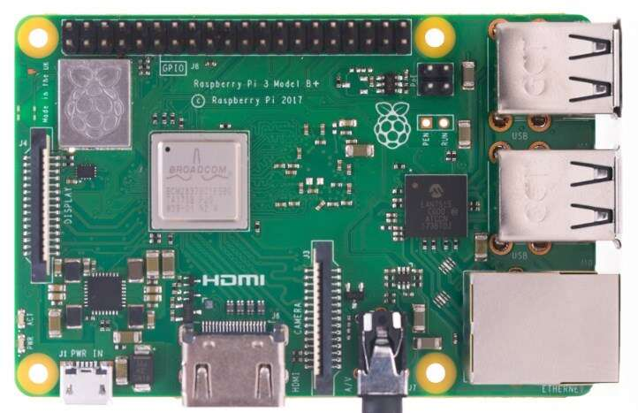

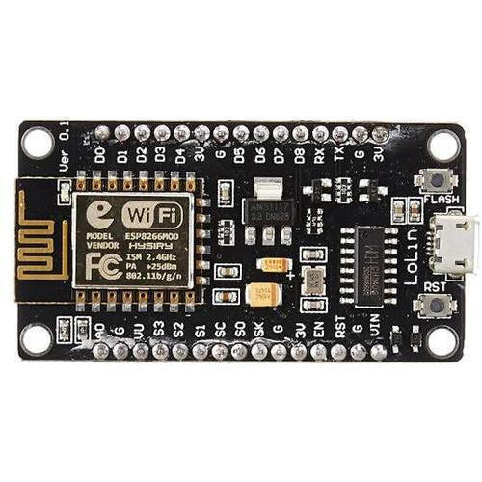

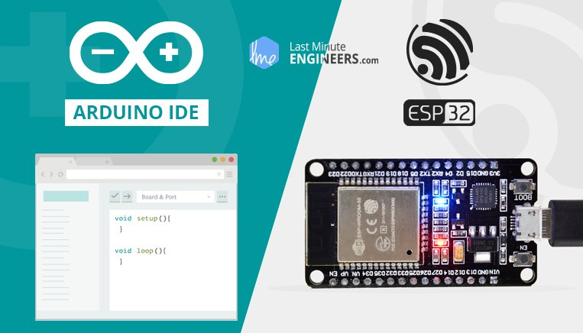

PRACTICAL_03

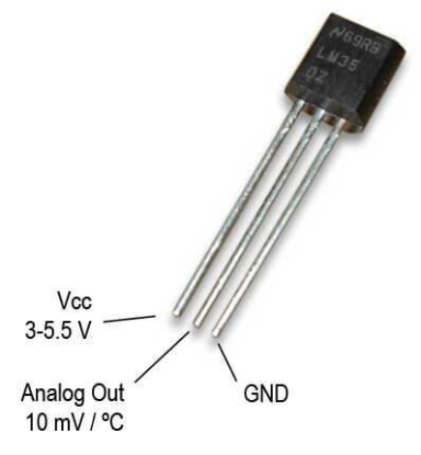



PRACTICAL_04

PRACTICAL_05

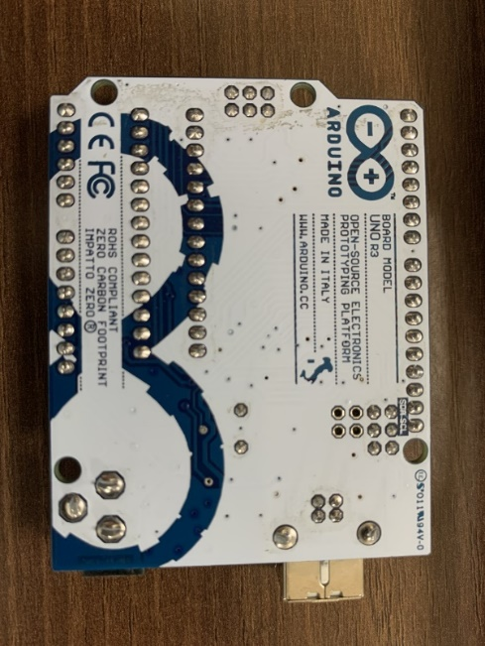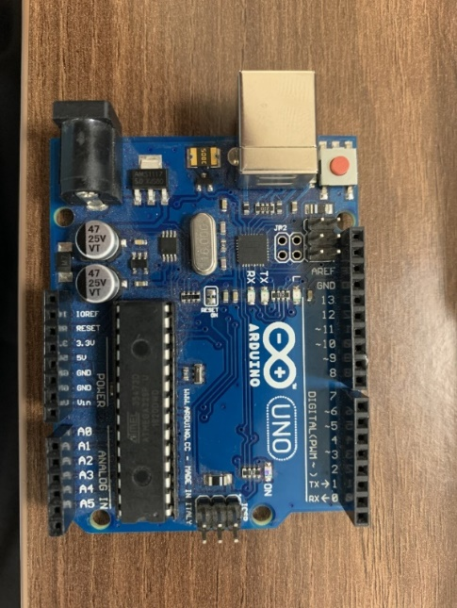

PRACTICAL_06



PRACTICAL_07



